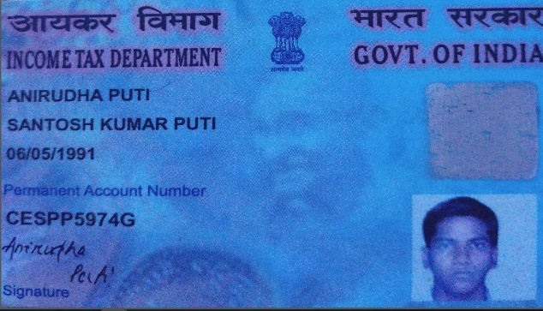

Anirudha Puti
GIS Developer
In GIS ﬁeld with around 6.6+ years of experience in the IT industry brings forth a unique set of knowledge and skills which include an in - depth understanding of various business domains like energy & utilities - Oil & Gas, Electric, Land base and Navigation. In that 3+ years experience in developing ESRI GIS desktop, web application using python, Arcobject, .NET, Geoprocessing tools & server object extension. |Agile Project management | Software development life cycle(SDLC)|.

WORK EXPERIENCE
anirudhaputi28@gmail.com
8763823270
Odisha, India

GIS Developer

Tata Consultancy Services (TCS)
07/2022 - 06/2023,
Achievements/Tasks
Developed and Supported multiple ESRI Arcmap add-ins custom tools using
.NET & python.
Worked on incident and task in existing desktop application.
Implimentation of new Enhancement task according to bussiness requirement in existing desktop application.

Senior Process Exicutive

Infosys BPM Ltd.
10/2019 - 07/2022,
Achievements/Tasks
Developed multiple ESRI Arcmap add-ins custom tools using .NET & python.
Programming and executing Python/Arcpy scripts and Geoprocessing scripts.
Developed arcmap edit capture tools & automated report generated tools.
Designed and coded the application using HTML5, CSS, C#, ASP.NET, Web API, JavaScript, JSON.
A grasp of python and arcpy for providing custom tools to improve workﬂows.

GIS Engineer

IIC Technologies Ltd.
06/2016 - 06/2019,
Achievements/Tasks
Working on GIS application design, development, and implementation.
Create, analyze, and maintain maps, data, and reports Using ESRI products and technology .
Assist GIS product and tool users with day-to-day production support.
Create a Base Map, Build Land Base Project. Building, Area, Road Geometry, Attribution, Merging, Parcel Mapping, Poi Data Veriﬁcation, Create new Buildings & Topology.
Developed validation tool for quality checks of GIS data.

EDUCATION

B. Tech

Biju Patnaik University of Technology(BPUT)
ODISHA, INDIA

12th

HARAPRAVA MAHABIDYALAYA (CHSE)
ODISHA, INDIA

SKILLS
Python
arc GIS Pro

arcGIS Desktop
autoCAD
ArcGIS

HTML5
CSS
JAVA Script

SQL server
Web APIs
C#

ASP.NET
Django Framework
GIT

Github
Geoserver
Openlayers

Leaﬂet

LANGUAGES
English
Full Professional Proﬁciency

Hindi
Full Professional Proﬁciency

Odia
Full Professional Proﬁciency

